 BALDIVIS SECONDARY COLLEGE
Name:_____________________
Mathematics Foundation Program UNIT 4 Semester 2
Task 15 Practical Application: Decorate and furnish your bedroom on a budget
Task weighting: 6 % of the school mark for this pair of units. Total Marks /50
Resources: Copy of a house plan, rulers, calculators, computers, internet connection and excel.
You have become involved with Ronald McDonald House you have been asked to decorate a bedroom for child who is undergoing treatment.
You will need to purchase a bed base, mattress, bedside cabinet, lamp, chest of drawers, curtains to fit the window, bed sheets, quilt cover, 2 pillows and 2 cushions.
To decorate the bedroom you will also need to purchase at least two pictures to hang on the walls.
You only have a Budget of $1500.

Task 1 CREATE A WORD DOCUMENT
- Use the internet to search for all the items needed for your bedroom. Copy and paste photos of your items in your word document. All items must include all the dimensions (sizes) and prices.

Task 2 CREATE AN EXCEL SPREADSHEET
- Create a spreadsheet in excel to show all your expenses and total.
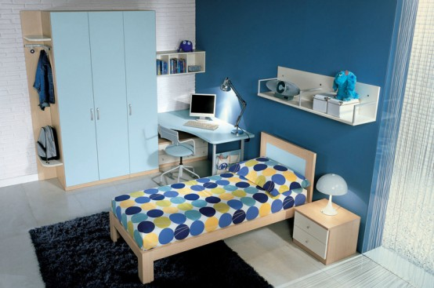

Task 3 [12 Marks}
- Write all the dimensions on your plan using the scale provided. State the real lengths of all the doors, window and walls of your bedroom. (Scale: 1:20)

- On your given scale drawing of your bedroom draw a top view of your bed, dressing table, bedside cabinet, lamp, pictures, and tallboy. (Scale: 1:20) Ensure that you label and write the real length of your furniture.

- State any savings from your budget. Write one extra item you could purchase for your room and provide a reasonable explanation.

- Communicate two ways you could save money when furnishing you bedroom.

